LTspice Diode Characteristics Lab

Seth Ricks

ECEN 350

Brother Swenson

ECEN 350 – LTspice Diode Characteristics Lab (50 points)
(jas, LTspice Diode Characteristics Lab.docx, 5/16/2025)

Note: This is a CAD lab to be done individually, rather than in teams, although please help each other out if/when opportunities arise, while still avoiding plagiarism. Submit an electronic version of a lab report to receive credit for doing this lab. The goal of your lab report is to provide sufficient documentation so that the lab can be repeated if necessary. Therefore, simply add to this document to arrive at your lab report, as all of the explanatory text, procedures, and Discussion and Conclusion questions contained in this document are required for a complete lab report. So, for your lab report, add a cover page, your results, and your answers to the Discussion and Conclusions questions to the existing lab document. Your answers to the Discussion and Conclusions questions are to be uniquely yours and not a copy of someone else’s answers to these questions. Your cover page is to include class, lab title, and author. A grading rubric for this lab is included at the end of this document. The rubric does not need to be included in your lab report.

Purpose: To become more familiar with the characteristics of standard silicon pn junction diodes along with silicon metal Schottky diodes using comprehensive diode spice models and LTspice.

Procedure:

Part 1 – Diode IV Characteristics

- Build the circuit illustrated below in Figure 1 in LTspice. (Note: The Figure 1 simulation circuit results in a simulated forward current of over 10 A for the 1N5819 Schottky diode for a V_{S} supply voltage of 1 V. While this would be destructive to an actual 1N5819 diode, it is not a problem for the computer simulation intended to compare the forward knee voltages of the two different diodes.) For the 1N4007 and 1N5819, first place a standard diode from the main LTspice library. These diodes then need to be configured for the appropriate models. To change from the standard diode model, hover the mouse over the diode in the schematic and then right click, which opens a Diode pane. Then click on the Pick New Diode box, which opens a Select Diode window with many diode possibilities. For the 1N5819, it is suggested to sort on the “type” of diode in this window to narrow down the search and then look through the Schottky diode options to find the 1N5819. Selecting the 1N5819 model from the Select Diode window then updates the associated diode model and modifies the schematic diode symbol to the symbol for a Schottky diode. The diode type can also be changed simply by editing the value from D to 1N4007 or 1N5819 on the schematic, although this approach does not modify the schematic symbol for Schottky diodes. There is now an older and newer version of LTspice, with some nomenclature differences between the two versions. The older version includes a .op for Operating Point icon along the top toolbar, whereas the newer version uses .t for the same function, which opens a Spice Directive window. A Spice Directive window can also be opened by choosing Spice Directive in the Edit pull-down menu in the upper left-hand corner of the LTspice window. A Spice Directive window is where simulation commands are entered for inclusion on an LTspice schematic.
- On the Edit pull-down menu in the upper left-hand corner, choose Spice Analysis which opens an Edit Simulation Command pane. Set the DC Sweep parameters as follows: .dc Vs -1 1 0.001, which sweeps the independent voltage source Vs from -1 V to 1.0 V in 1 mV increments.
- In the Edit pull-down menu, add your name to your schematic as follows for the older version: Edit Aa Text.
- When completed with your schematic, replace the schematic shown in Figure 1 below with your version, including your name. (8 points.)
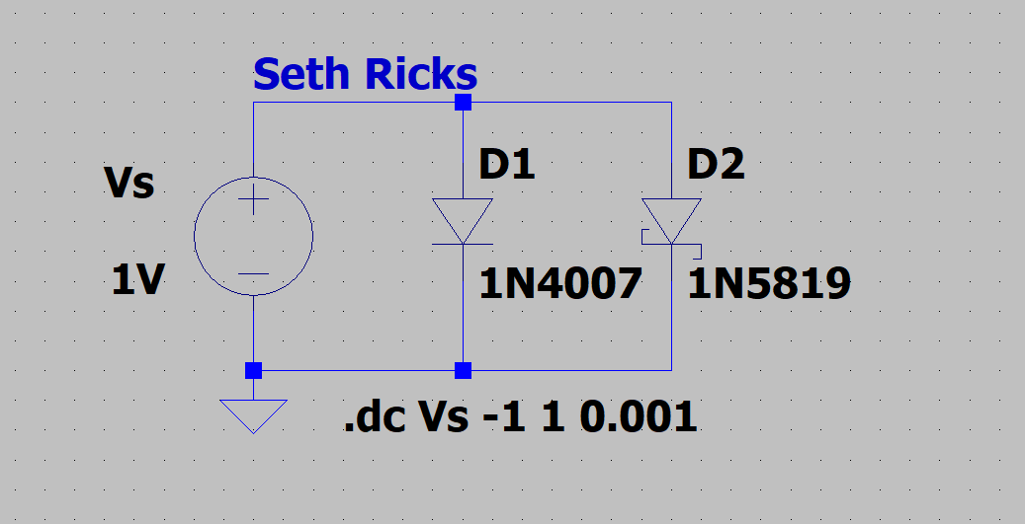
Figure 1: LTspice Circuit for Characterizing Diode Performance.

- After running the simulation, Click on the opened window, go to Plot Settings Add trace, and select the waveforms I(D1) and I(D2) for display.

Note: LTspice uses a dark background for the default plot pane, which makes it hard to visibly see some trace colors such as dark blue. The Tools Control Panel Waveforms Color Scheme Background allows you to modify the background color with Red = Green = Blue = 255 resulting in a white background. This is an optional change that you may find improves waveform viewing. If you make this change, it is also recommended to navigate to Tools Control Panel Waveforms and change the Data Trace and Cursor width from 2 to 3, along with using a Bold Font for the waveform labels so that the traces, cursors are waveform labels are more easily visualized.

- Next limit the diode current axis in the plot pane as follows: Go to Plot Settings Manual Limits, which opens a Plot Limits pane as shown below to be used to set the vertical axis limits at -0.1 A to 1.1 A in 0.1 A divisions.

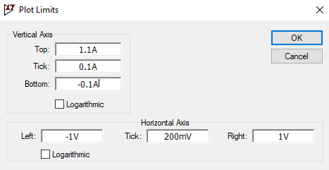

Figure 2: LTspice Plot Limits Pane.

- Next attach one cursor to I(D1) and the other cursor to I(D2). Then adjust the I(D1) cursor to a voltage of 700 mV, which is a commonly used approximation for the forward bias voltage of a silicon pn junction diode. Then adjust the I(D2) cursor to a voltage of 300 mV, which is a commonly used approximation for the forward bias voltage of a silicon Schottky diode. Both the mouse and the left and right arrow keys can be used to move the waveform cursors along a given trace.
- Then drag the cursor pane onto your plot to document your diode current values as illustrated in the figure below.
- Finally, in the Plot Settings pull-down menu on the main LTspice toolbar, annotate your plot with your name as follows: Plot Settings Notes & Annotations Place Text.
- Replace the plot pane shown in Figure 3 below with your version, including your name, along with the cursor pane indicating diode currents. (7 points.)
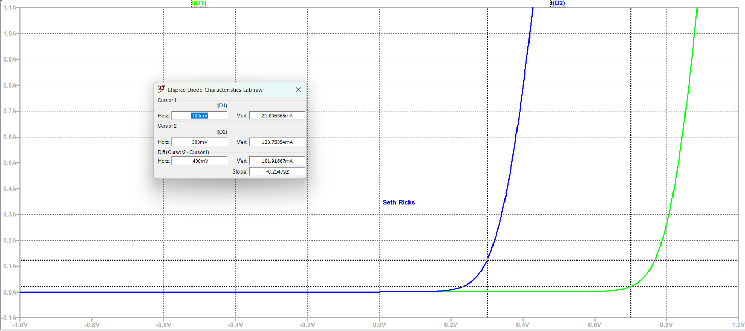
Figure 3: I-V Characteristics of a 1N4007 silicon pn junction diode and a 1N5819 Schottky Diode.

- Using the waveform cursors and three significant figures, calculate and record below the bulk resistance of the 1N4007 occurring at V_{d} = 0.75 V for your Figure 1 circuit. (Note: Bulk resistance is calculated as ΔV/ΔI and is meant to approximate dV/dI at the point of interest. Hence, choose ΔV values that are slightly above and below the Vd = 0.75 V data point and use the associated ΔI values for your calculation.) (2 points.)
$$751mV→ 83.427548mA$$
$$749mV→ 79.304956mA$$
$$R_{B}=\frac{V_{2}-V_{1}}{I_{2}-I_{1}}=\frac{751*{10}^{-3}-749*{10}^{-3}}{83.427548 {* 10}^{-3}- 79.304956{* 10}^{-3}}=0.485 Ω$$

R_{B} = 0.485 $Ω$

- Using the waveform cursors and three significant figures, calculate and record below the bulk resistance of the 1N5819 occurring at V_{d} = 0.3 V for your Figure 1 circuit. (Note: Bulk resistance is calculated as ΔV/ΔI and is meant to approximate dV/dI at the point of interest. Hence, choose ΔV values that are slightly above and below the Vd = 0.3 V data point and use the associated ΔI values for your calculation.) (2 points.)

$$301mV→ 126.74327mA$$
$$299mV→ 120.8239mA$$
$$R_{B}=\frac{V_{2}-V_{1}}{I_{2}-I_{1}}=\frac{301*{10}^{-3}-299*{10}^{-3}}{126.74327 {* 10}^{-3}- 120.8239{* 10}^{-3}}=0.338 Ω$$

R_{B} = 0.338 $Ω$

Part 2 – Reverse Leakage Characteristics

- Connect up the circuit illustrated below in Figure 4 with the voltage source Vs set to -10 V in order to reverse bias the two diodes. Note: Change the previous .dc Vs -1 1 0.001 statement an .op operating point statement and add the .step temp -55 125 5 parameter sweep statement by means of Spice Directive.
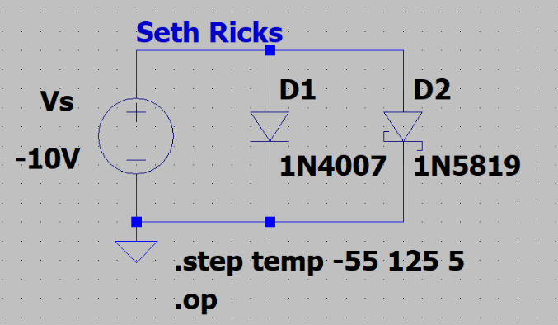
Figure 4: LTspice Diode Leakage Current Simulation Circuit.

- After running the simulation, a Plot Pane will open in which you are to select the waveforms I(D1) and I(D2) for display. Attach one cursor to I(D1) and the other cursor to I(D2).
- Next with the waveform cursors, record the reverse biased diode leakage currents for each of the following temperatures listed below in Table 1, using three significant figures and including the sign and units. (12 points.)

Table 1: Diode Voltage and Current Values at 10 V Reverse Bias over Temperature.
Diode Temperature (˚C) | I(D1) | I(D2)
-55 ˚C | -9.9475983pA | -13.417868nA
0 ˚C | -13.500312pA | -4.0489003µA
25 ˚C | -82.156504pA | -27.556625µA
70 ˚C | -5.5953464nA | -439.69243µA
85 ˚C | -18.827651nA | -953.53922µA
125 ˚C | -311.87466nA | -5.7118344mA

Discussion and Conclusions Questions: (For the following questions use your own words along with complete sentences. Points are to be deducted for AI generated answers.)

- Given the I-V characteristics of the 1N4007 and 1N5819 diodes in Figure 3, which diode has the largest forward (static) resistance in the forward biased region? (1 point.)

The 1N4007 diode has the largest forward resistance. This can be seen in Figure 3, where the plot for this diode is further to the right. This means that with the same current, this diode has more voltage than the other. Thus, there is more static resistance.

- Explain why the reverse leakage current of the silicon pn junction diodes increases with increasing temperature. (Note: The reverse leakage current in Schottky diodes is larger than silicon pn junction diodes, but more difficult to explain and so not addressed in this course.) (4 points.)

As the temperature increases, the electrons inside the diode have more energy. This means that they are more able to cross the threshold barrier when a reverse bias is applied.

- Explain whether a silicon pn junction diode or a silicon metal Schottky diode is more like an ideal diode regarding forward voltage. (2 points.)

An ideal diode, with the first approximation, will conduct with a zero volt drop across it. Because the knee voltage of a silicon metal Schottky diode is 0.3V and a silicon pn junction diode is 0.7V, the Schottky diode is closer to an ideal diode.

- Explain whether a silicon pn junction diode or a silicon metal Schottky diode is more like an ideal diode regarding reverse leakage current. (2 points.)

In reverse bias voltage, an ideal diode will have no current. The Schottky diode has more reverse leakage current than the pn junction diode. In this sense, the silicon pn junction diode is more like an ideal diode with reverse bias.

- Based on your Table 1 data, which direction does conventional current flow in a reverse biased diode, i.e., anode-to-cathode, or cathode-to-anode? (2 points.)
Conventional current flows from cathode-to-anode in a reverse biased diode. This is opposite from the normal flow of conduction, which is usually from positive to negative.

- Explain whether a silicon pn junction diode or a Schottky diode would have a higher junction temperature for both diodes conducting the same forward current and having the same junction-to-ambient thermal resistance and ambient temperature. (2 points.)
The pn junction diode would have a higher junction temperature. With the same current, the pn junction diode has a higher voltage across it. This means that it is dissipating more power, and thus it is dissipating more heat.

LTspice Diode Characterization Lab Grading Rubric: This is a CAD lab to be done individually, rather than in teams, although please help each other out if/when opportunities arise, avoiding plagiarism. Submit an electronic version of a lab report to receive credit for doing this lab. The goal of your lab report is to provide sufficient documentation so that the lab can be repeated if necessary. Therefore, simply add to this document to arrive at your lab report, as all of the explanatory text, procedures and Discussion and Conclusion questions contained in this document are required for a complete lab report. So, for your lab report, add a cover page, your results, along with your answers to the Discussion and Conclusions questions to the existing lab document. Your answers to the Discussion and Conclusions questions are to be uniquely yours and not a copy of someone else’s answers to these questions. Your cover page is to include class, lab title, and author. The rubric does not need to be included in your lab report.
Lab Report Item | Points
Cover Page | 2
Part 1 – Diode IV Characteristics  Figure 1: (8 points total. 1 point for correct voltage source, 2 points for 1N4007 diode type, 2 points for 1N5819 diode type, 2 points for .dc Vs -1 1, 0.001 statement, 1 point for name included on schematic).  Figure 3: (7 points total – 1 point for I(D1) trace, 1 point for I(D2) trace, 1 point for -0.1A to 1.1A vertical plot limits, 1 point for cursor pane included on the plot pane, 1 point for I(D1) current value near to 22 mA at 0.7 V, 1 point for I(D2) current value near to 124 mA at 0.3 V, 1 point name included on the plot pane.)  Bulk Resistance of 1N4007: (2 points.)  Bulk Resistance of 1N5819: (2 points.) | 19
Part 2 – Reverse Leakage Characteristics  Table 1 values with units.  (12 points total - 1 point per entry, -0.25 point for each missing unit.) | 12
Discussion and Conclusions | 13
Grammar and Professionalism | 4
Total | 50

Please give feedback on errors you find in this document.

